Supplementary Materials
Figs.S1-Figs.S4
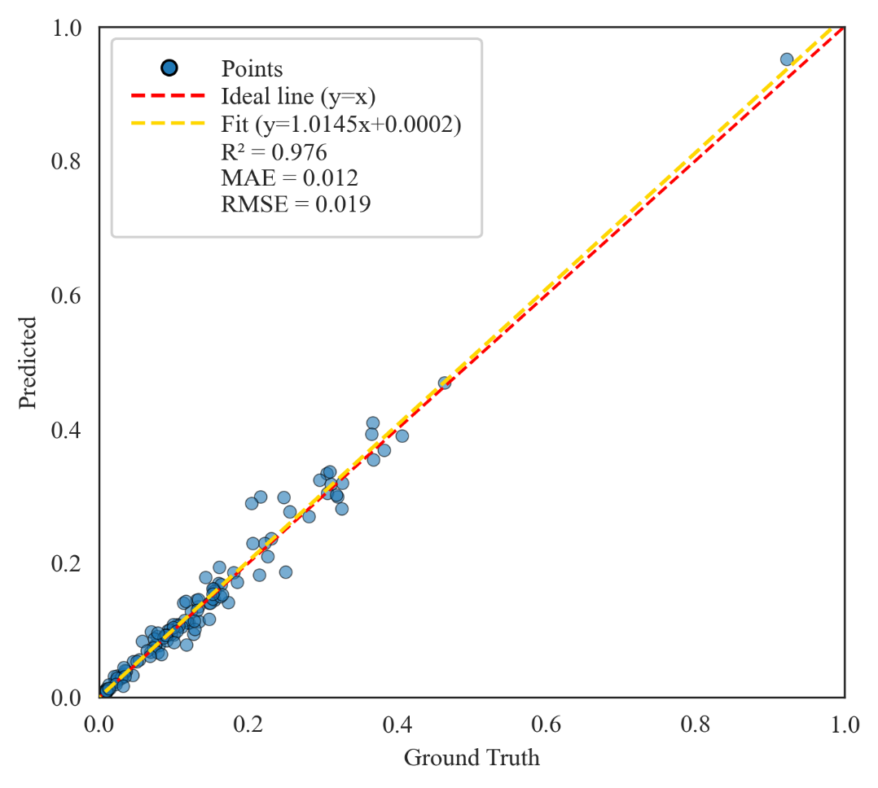
Fig.S1. Regression analysis of disease severity predicted by the proposed SimEffB0-RepUNet model against the ground truth values. The x-axis represents the ground truth, while the y-axis denotes the predicted values. Each scatter point reflects the deviation between the predicted result and the actual label for an individual sample.
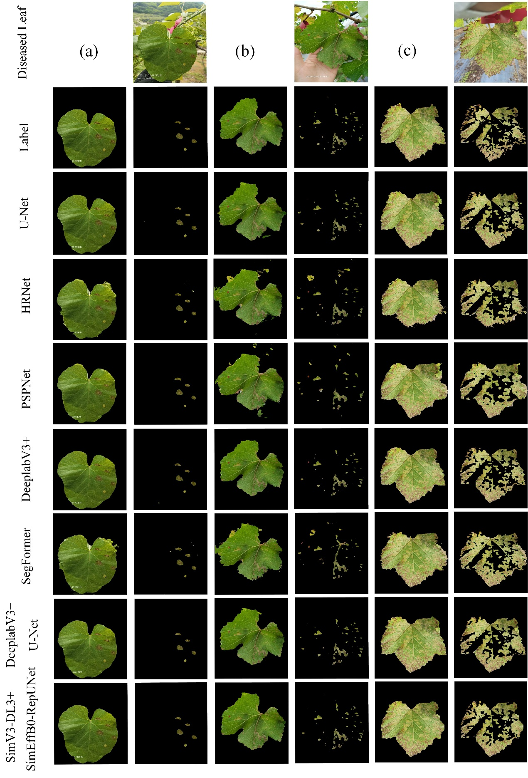
Fig.S2. The actual segmentation results on three images generated by the five single-stage models and the dual-stage models, including U-Net, HRNet, PSPNet, DeepLabV3+, SegFormer, DeepLabV3+U-Net, and SimV3-DL3+SimEffB0-RepUNet.
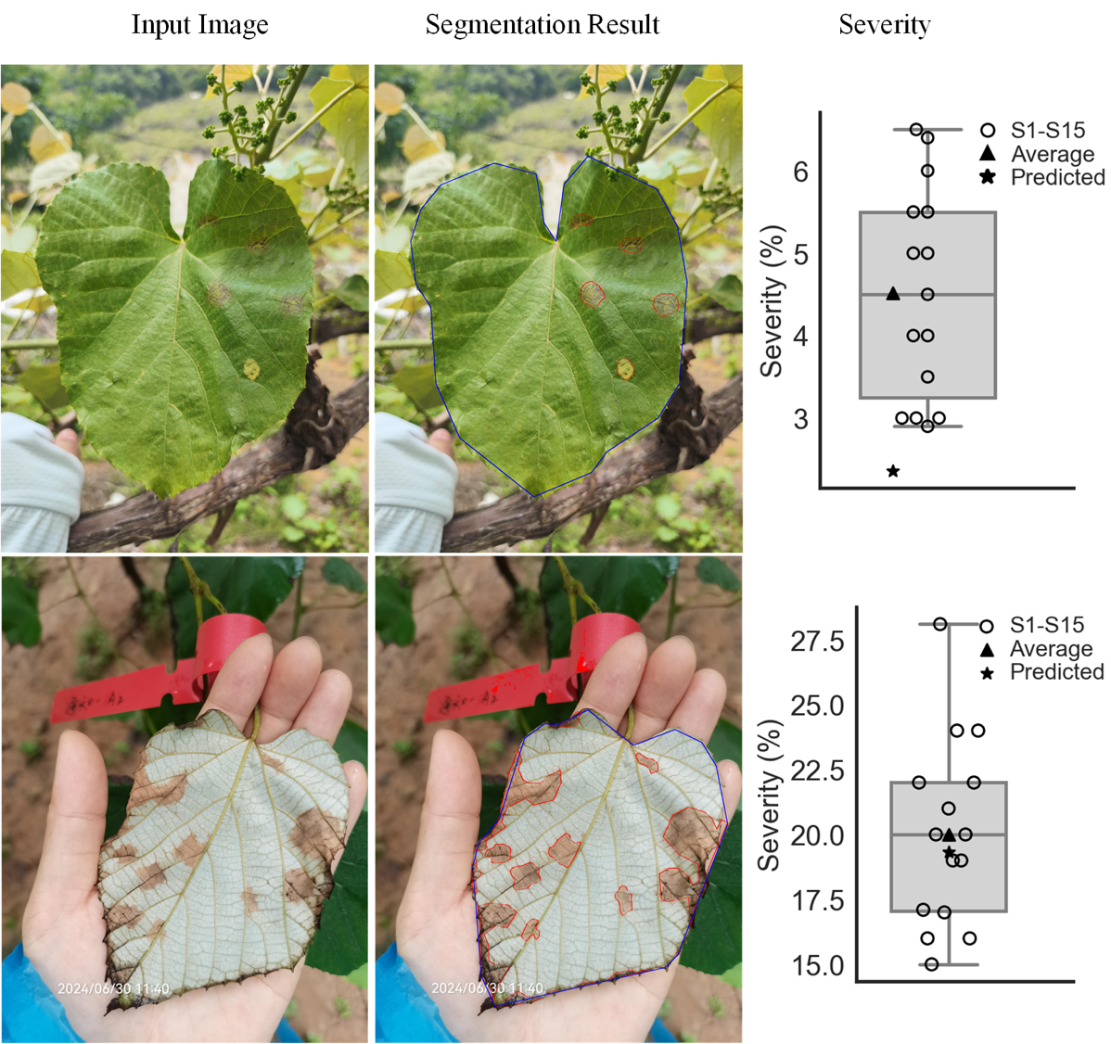
Fig.S3. Illustrative comparison of predicted severity with expert visual estimates, where S1-S15 represent the expert visual estimate, average for the average value of the total 15 expert estimates, and predicted for predicted severity with our model.
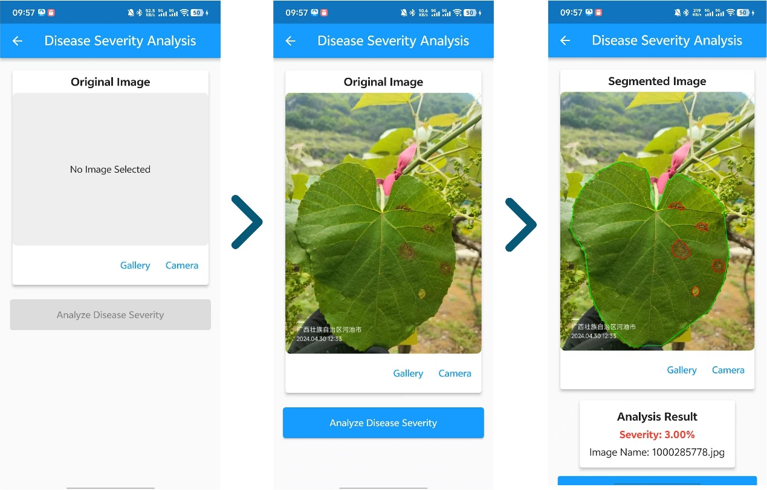
Fig.S4. The Mobile application and its pipeline for leaf disease severity estimation.

